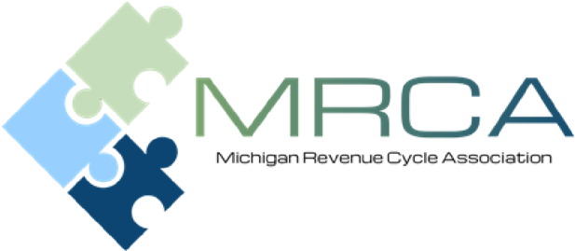
Dear Corporate Partner,
For over 30 years MPAA and MAHAP has provided speakers, industry updates, professional development and training resources to Patient Accounting and Revenue Cycle professionals and MRCA will continue to do the same. We recognize that 2020 was a challenging year. A year like no other we have experienced. We continue to be grateful that we have been able to unite together through a virtual platform to continue to bring educational and networking opportunities to our membership and sponsors.
As we look ahead to the 2021-2022 program, we are remaining positive that with the vaccines we will be networking in person as soon as possible. We still have a long road ahead. We are planning to continue to provide virtual events through most of 2021.
With this being the case, we felt it was appropriate to design a different type of sponsorship program. For the 2021-2022 membership year, we will be offering a platform for you to remain in engaged with our membership through virtual meetings and website options. We have updated our website to offer more recognition opportunities.
We appreciate your support and remind you that the program is invaluable for both our Corporate Partners and the MRCA membership.
As a Corporate Sponsor you will benefit from:
- Networking opportunities with
- Decision makers from hospital billing and business offices throughout Michigan.
- Peers from corporations and organizations similar to yours.
- Recognition as an industry leader and supporter of MRCA’s professional development and program initiatives.
- Exposure to industry experts, quality speakers, healthcare billing and reimbursement trends.
- Value…providing maximum return on your sponsorship and marketing investment.

The enclosed form outlines the Corporate Sponsorship program and benefits provided for each level. Please consider becoming a Corporate Sponsor for 2021-2022 by either renewing your sponsorship or becoming a Corporate Sponsor for the very first time. It is through your participation and support that we can continue to offer quality education and professional development to medical professional throughout the state.

We look forward to having you as a Corporate Sponsor and seeing you in person as soon as we can!
Sincerely,

Robin Beeman
MRCA Sponsorship Chair
586-876-5013
robin.beeman@meddata.com
Corporate Sponsorship Program 2021-2022
Benefit | Gold |  | Silver | Value
Spotlight at a Membership Meeting (special introduction at a meeting (virtual or in-person to say a few words to the group) | X |  |  | $150
Verbal Recognition at meetings | X |  | X | $100
Advertisement, corporate logo and link on MRCA website | X |  | X | $150
Sponsorship acknowledgement on MRCA website | X |  | X | $50
Marketing Material page on MRCA website | X |  |  | $300
2 Speaker introductions | X |  |  | $100
Sponsorship acknowledgement via video screen during opening or closing remarks at all meetings | X |  | X | $50
Sponsorship Value | $900 |  | $350
Sponsorship Cost | $500 |  | $275

Additional Sponsorship Opportunities:
- We typically have a special speaker at our last membership meeting of the year. To help defer cost for our May 2022 meeting; we are asking you to please consider supporting our speaker. We will acknowledge your sponsorship verbally and with signage.
- Advertisement, corporate logo and link on MRCA website: $150.
Michigan Revenue Cycle Association
2021-2022 Corporate Sponsors

Mail your check to the address below or CLICK HERE to register on-line.

Meeting dates for the 2021-2022 year will be available soon, however the months are as follows:
November
January
March
May

Depending on the sponsorship level you choose, I will need the following from you.
  - Website links and logos if we do not currently have them.
  - For the gold sponsors, we need your logo, chosen marketing document as well as a small one paragraph bio.

Please complete form and mail to:

Robin Beeman
16472 Crosswind Lane
Macomb Township, MI 48042

Thank you for your generous support! Feel free to contact me if you have any questions or need additional information.

Robin Beeman
MRCA Sponsorship Chair
586-876-5013
robin.beeman@meddata.com

