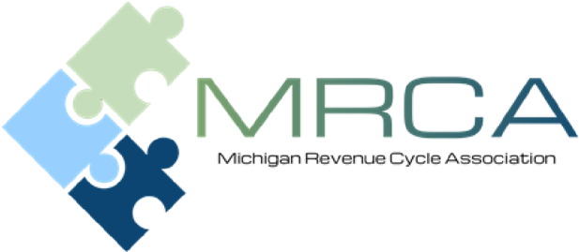
Dear Corporate Partner,
For over 30 years MPAA and MAHAP has provided speakers, industry updates, professional development and training resources to Patient Accounting and Revenue Cycle professionals and MRCA will continue to do the same. We recognize that 2020 and most of 2021 have been challenging. We continue to be grateful that we have been able to unite through a virtual platform and continue to bring educational and networking opportunities to our membership and sponsors.
As we look ahead to the 2021-2022 program, we remain positive that with the vaccines we will be networking in person again soon. We continue to monitor the pandemic so we can continue to provide our educational events in the safest manner possible. Our hope is that we will once again be meeting in person.
With this being the case, we felt it was appropriate to design a different type of sponsorship program. For the 2021-2022 membership year, we will be offering a platform for you to remain engaged with our membership through virtual meetings, website options and hopefully in person events. We have updated our website to offer more recognition opportunities.
We appreciate your support and remind you that the program is invaluable for both our Corporate Partners and the MRCA membership.
As a Corporate Sponsor you will benefit from:
- Networking opportunities with
- Decision makers from hospital billing and business offices throughout Michigan.
- Peers from corporations and organizations similar to yours.
- Recognition as an industry leader and supporter of MRCA’s professional development and program initiatives.
- Exposure to industry experts, quality speakers, healthcare billing and reimbursement trends.
- Value…providing maximum return on your sponsorship and marketing investment.
The enclosed form outlines the Corporate Sponsorship program and benefits provided for each level. Please consider becoming a Corporate Sponsor for 2021-2022 by either renewing your sponsorship or becoming a Corporate Sponsor for the very first time. It is through your participation and support that we can continue to offer quality education and professional development to medical professional throughout the state.
We look forward to having you as a Corporate Sponsor and seeing you in person as soon as we can!

Sincerely,

Robin Beeman
MRCA Sponsorship Chair
586-876-5013
robin.beeman@meddata.com

Andrea Ronse
MRCA Sponsorship Co-Chair
443-886-4351
aronse@trendhealthpartners.com

Corporate Sponsorship Program 2021 – 2022

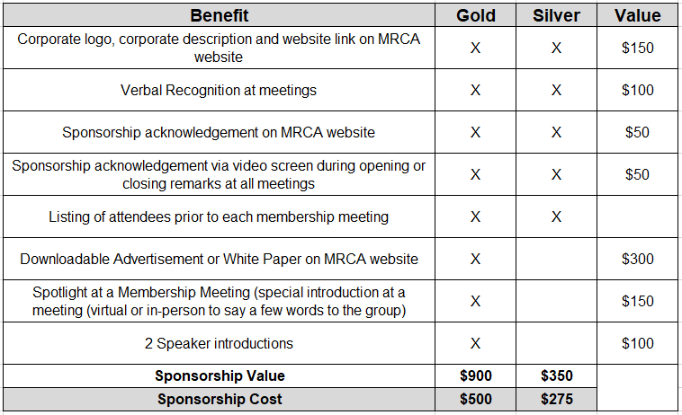

Additional Sponsorship Opportunities:
- We typically have a special speaker at our last membership meeting of the year. To help defer cost for our May 2022 meeting; we are asking you to please consider supporting our speaker. We will acknowledge your sponsorship verbally and with signage.
- Corporate logo, corporate description and website link on MRCA website: $150.

Michigan Revenue Cycle Association
2021-2022 Corporate Sponsors

Mail your check to the address below or CLICK HERE to register on-line.

Meeting dates for the 2021-2022 year are listed below. We are planning for in-person meetings, however this could change due to the pandemic and State requirements.
- November 13, 2021- Planning in person in Okemos, MI
- January 21, 2022 – Planning in person in Okemos, MI
- March 18, 2022 – Planning in person in Okemos, MI
- May 4th-6th, 2022 – Spring Conference

Depending on the sponsorship level you choose, the following will be needed:

  - Website link
  - Logo – Please utilize *.JPG, *.GIF, or *.PNG as the format no larger than 320x100
  - Corporate description
  - For the gold sponsors, please also include the following:
    - Chosen advertisement or white paper – this can be in PDF format

Please complete form and mail to:

Robin Beeman
16472 Crosswind Lane
Macomb Township, MI 48042

Thank you for your generous support! Feel free to contact one of us if you have any questions or need additional information.

Robin Beeman
MRCA Sponsorship Chair
586-876-5013
robin.beeman@meddata.com

Andrea Ronse
MRCA Sponsorship Co-Chair
443-886-4351
aronse@trendhealthpartners.com

